OOP Assessment Stage 7

Create the following new JFrame-
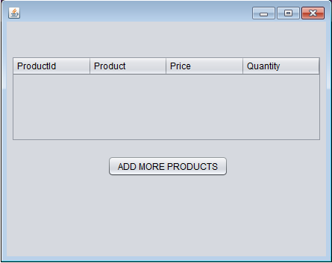

This should act like a basket and when added to (and viewed), should look like the following:
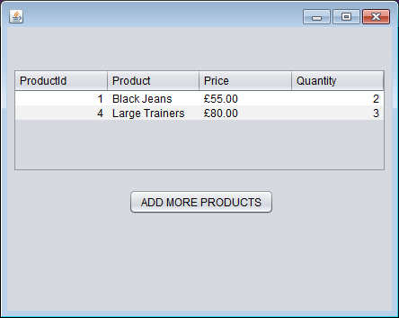
Please note: The 'Add More Products' button should not be active at this stage.
Code this new page and the Shop page so that when you select a Product on the Shop page, and enter a valid quantity (so a quantity equal to or below the stock level) and then click 'Add To Basket' you can now view it on this Basket page.
At this stage the same products won’t be combined into 1 orderLine, if you order 2 lots of the same product then they will just be in 2 separate orderlines.

